**Project Report**

1. **INTRODUCTION**

* Smart waste management system in metropolitan cities is about using technology and data to create a more efficient waste industry based on IOT technology

**1.1 Project Overview**

* The project is based on a real-time smart garbage bin mechanism for solid waste management in smart cities

**1.2 Purpose**

* A waste management system is the strategy an organization uses to dispose of, reduce, reuse and prevent waste

1. **LITERATURE SURVEY**

**2.1 Existing problem**

Heavy metals and other toxic compounds from landfills,

pollution.

**2.2 References**

1. Abhishek, K. S., Qubeley, L. C. F., & Ho, D. (2016,

August). Glove-based hand gesture recognition sign

language translator using capacitive touch sensor.

In 2016 IEEE International Conference on Electron

Devices and Solid-State Circuits (EDSSC) (pp.

334-337). IEEE.

<https://doi.org/10.1109/EDSSC.2016.7785276>

2. Ahmed, M. A., Zaidan, B. B., Zaidan, A. A., Salih, M.

M., & Lakulu, M. M. B. (2018). A review on

systems-based sensory gloves for sign language

recognition state of the art between 2007 and

2017. Sensors, 18(7), 2208.

<https://doi.org/10.3390/s18072208>

3. Ahmed, M., Idrees, M., ul Abideen, Z., Mumtaz, R., &

Khalique, S. (2016, July). Deaf talk using 3D animated

sign language: A sign language interpreter using

Microsoft's kinect v2. In 2016 SAI Computing

Conference (SAI) (pp. 330-335). IEEE.

<https://doi.org/10.1109/SAI.2016.7556002>

***2.3. Problem Statement Definition***

* Indiscriminate disposal of waste is a major issue in most developing countries' urban centers and poses a serious threat to the healthy living of the citizens. The fill level of waste in each of the containers, which are strategically situated across the communities, is detected using sensors.

**3. IDEATION & PROPOSED SOLUTION**

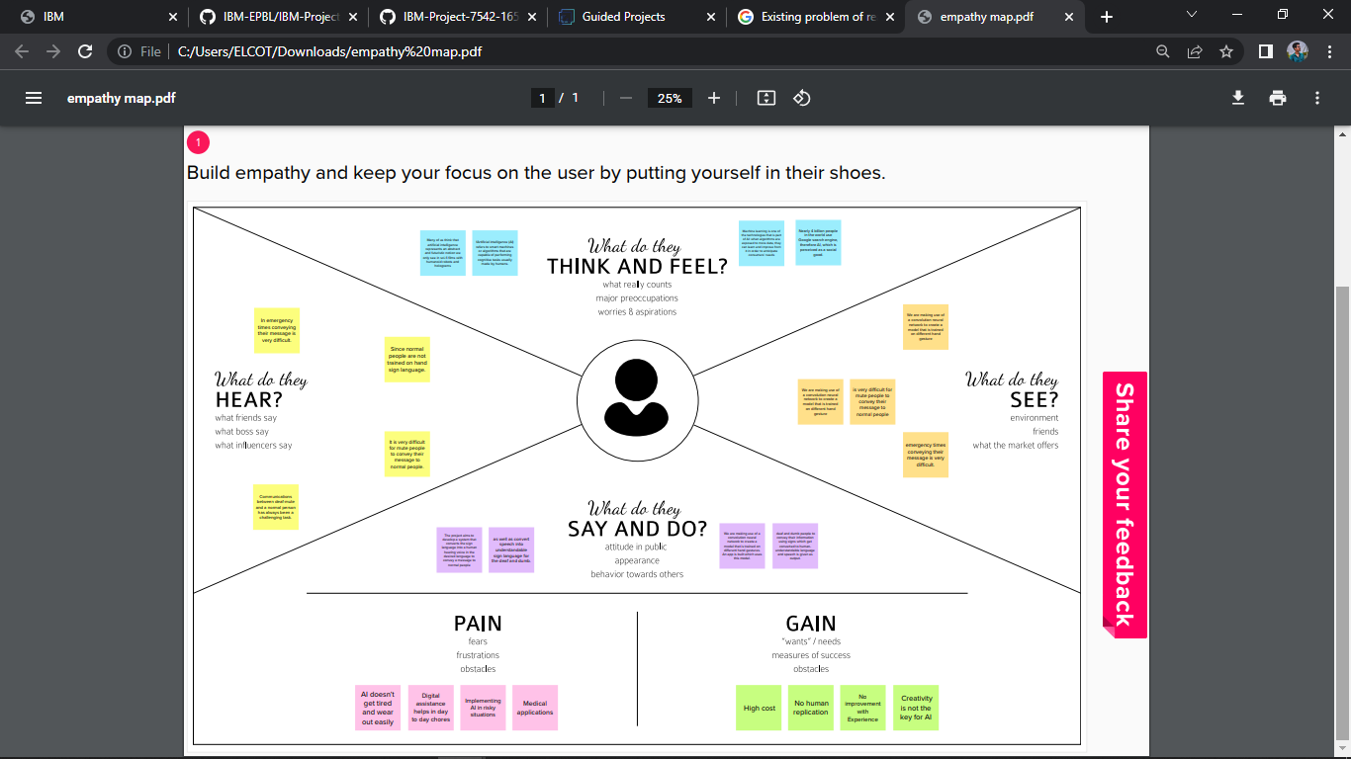 ***3.1. Empathy Map Canvas***

**3. 2. Ideation & Brainstorming**

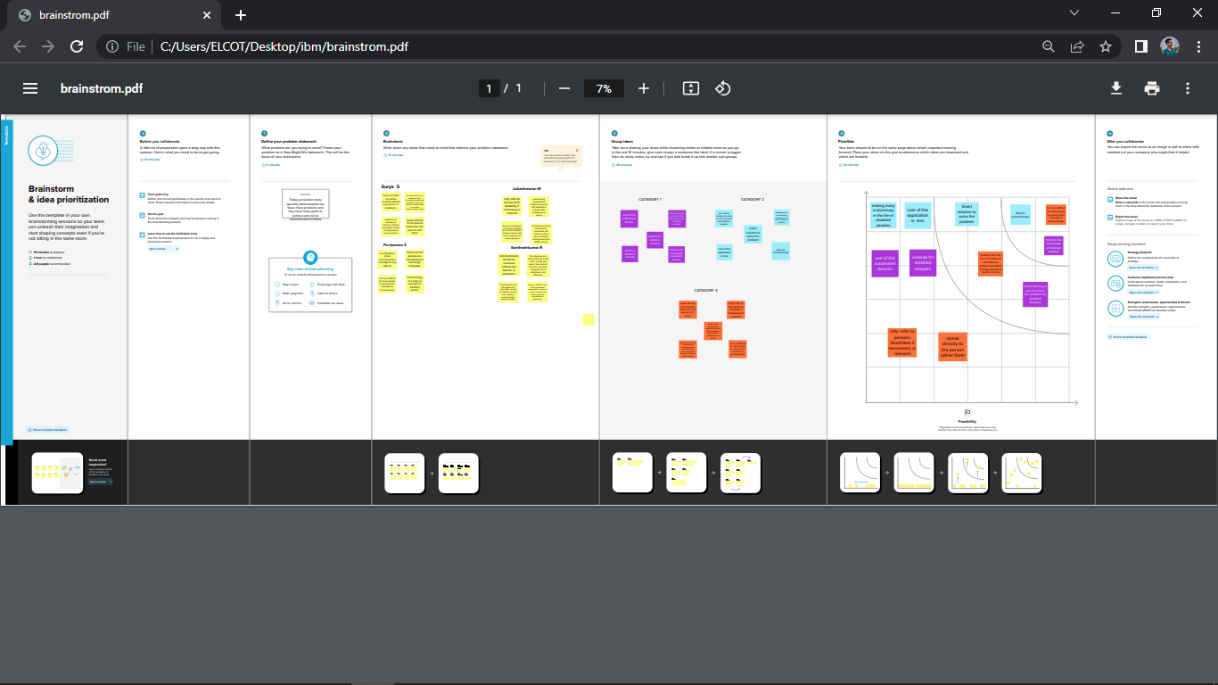

***3.3Proposed Solution***

|  |  |  |
| --- | --- | --- |
| **S.NO** | **PARAMETER** | **DESCRIPTION** |
| 1 | Problem Statement(problem to be solved) | We are making use of a convolution neural network to create a model that is trained on different hand gestures. |
| 2 | Idea / Solution description | Our main goal is to help unlock the hidden potential of many more visually impaired people through cutting – edge tech. |
| 3 | Novelty / Uniqueness | AI technology can empower people living with limited physical mobility. |
| 4 | Social Impact / Customer Satisfaction | AI can dramatically improve the efficiencies of our work places and can augment the work humans can do. |
| 5 | Business Model (Revenue Model) | Technology solutions can often multitask to reduce costs. For example , Lighting Control Systems provide an accessible control system, plus they can also be programmed to illuminate the home at a particular level to save energy costs. |
| 6 | Scalability of the Solution | The most frequent scalability consideration is performance. We want our software to become faster and more responsive as additional users, data, and features are added. If an application has 1000 client connections, it will have effectively scaled performance when its response times. |

**3.4**. ***Problem Solution fit***

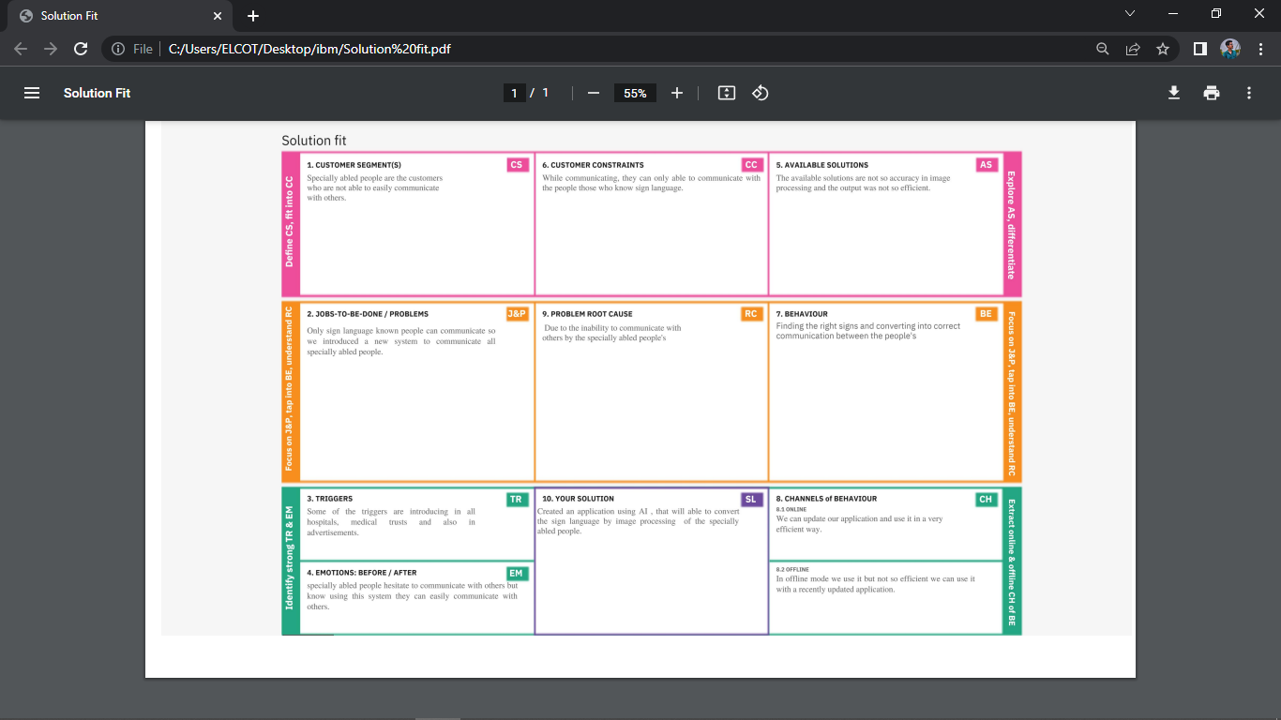

**4. REQUIREMENT ANALYSIS**

***4.1. Functional requirement***

|  |  |  |
| --- | --- | --- |
| FR No. | Functional Requirement (Epic) | Sub Requirement (Story / Sub-Task) |
| FR-1 | User Registration | LOWVISION:  A sauser who hastrouble reading ue to low  vision,want to be able to make the text largeron the screen so that I can readit.  Registration through Gmail |
| FR-2 | User Confirmation | IM PAIRED USER:  A sa user who is hearing impaired,  I want a turn on video captions so that I can understand what is being said invideos.  Confirmation via Email |
| FR-3 | User Registration. | COLORBLINDNESS:  A sauser who is color blind ,I want to link to be distinguishable on the page so that I can find the links and navigatethe site.  Registrationthrough Gmail |

1. ***2. Non-Functional requirements***

|  |  |  |
| --- | --- | --- |
| FR No. | Non-Functional Requirement | Description |
| NFR-1 | Usability | •Visualand Audio Help  •Text size scaling  •Reverse contrast |
| NFR-2 | Security | Important information:  •Walking in single file orin narrow space.  •Steps, Stair sand Slope.  •Ker bsand Roads. |
| NFR-3 | Reliability | To determine reliability measuresare:  •Test-Retest Repeatability  •Individual Repeatability |
| NFR-4 | Performance | To determine predictor so success in reading with low  Vision aids, interm so freading acuity, optimum  Acuity reserve, and maximum reading speed, for observers with low vision for various causes. |

**5. PROJECT DESIGN**

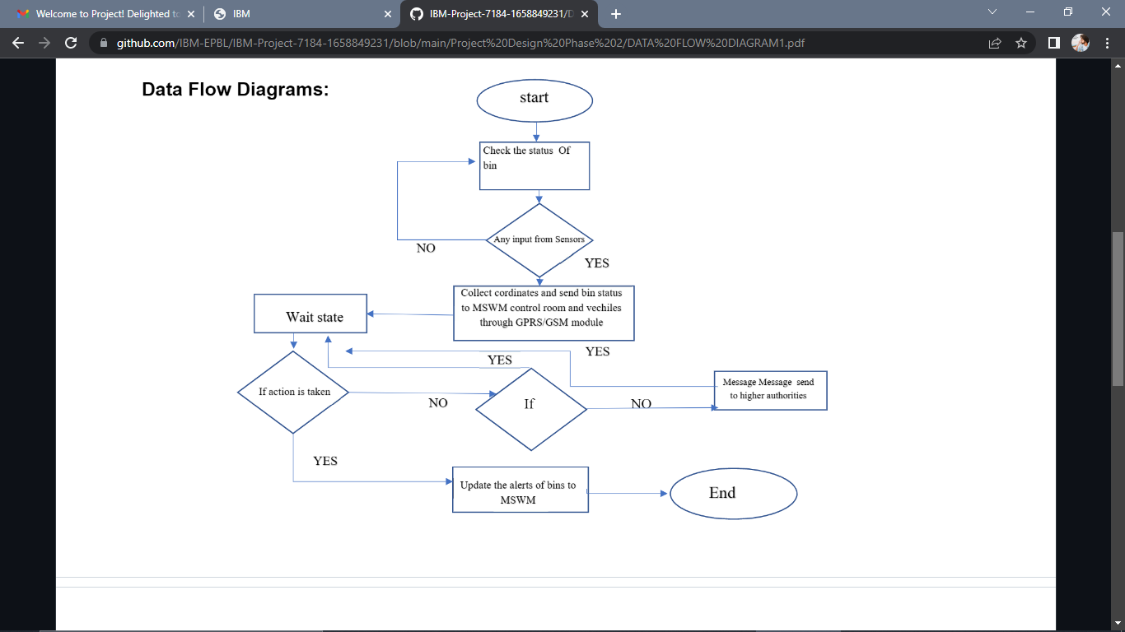 ***5.1. Data Flow Diagrams***

***5.2. Solution & Technical Architecture***

Technical Architecture:

Table-1 : Components & Technologies:

Table-1 : Components & Technologies:

|  |  |  |  |
| --- | --- | --- | --- |
| **S.No** | **Component** | **Description** | **Technology** |
| 1 | User Interface | User Interface provides options for the user to either upload a photo or turn on live camera for the prediction of sign language | HTML, CSS,  JavaScript/React JS |
| 2 | Application Logic-1 | The user input is taken and passed on to the model for feature extraction and prediction of the sign language. | Python |
| 3 | Application Logic-2 | The output is produced in speech format using the IBM Watson Text To Speech service. | IBM Watson TTS service |
| 4 | Database | The user login details and credentials are stored and processed using MySQL database. | MySQL. |
| 5 | Cloud Database | We use IBM cloud data storage to store and manage user data. | IBM DB2, IBM  Cloudant etc. |
| 6 | Machine Learning Model | Our Machine learning model is used to predict sign language with precision and accuracy. | Hand gesture recognition, etc. |
| 7 | Infrastructure (Cloud) | Our application is deployed using IBM Watson services | IBM watson services |

Table-2: Application Characteristics:

|  |  |  |  |
| --- | --- | --- | --- |
| **S.No** | **Characteristics** | **Description** | **Technology** |
| 1 | Open-Source Frameworks | Flask web application, Google colab | * HTML * CSS * Javascript * Flask * Google colab |
| 2 | Security Implementations | User login credentials and other details will be secured Using MD5 encryption and IAM Controls. | MD5, Encryptions, IAM Controls, OWASP etc. |
| 3 | Scalable Architecture | This project enables the developer to add more templates and it also paves the path to train themodel in-case if there is aneed to train the model with new sign language. | Technology used Machine learning |
| 4 | Availability | This is an open source application and it is available to all users and itmanage all the customers without any network glitch | Technology used Flask web application |
| 5 | Performance | This app will quickly upload and process the images because it predictsthe sign language using CNN model and it gives high accuracy. | Technology used |

|  |  |  |  |  |  |  |
| --- | --- | --- | --- | --- | --- | --- |
| **Sprint** | **Functional Requirement (Epic)** | **User Story Number** | **User Story / Task** | **Story Points** | **Priority** | **Team Members** |
| Sprint-1 | Registration | USN-1 | As a user, I can register for the application by entering my email, password, and confirming my password. | 2 | High | Surya S |
| Sprint-2 |  | USN-2 | As a user, I will receive confirmation email once I have registered for the application | 1 | High | Puviyarasu s |
| Sprint-1 | Login | USN-3 | As a user, I can log into the application by entering email & Password | 1 | Medium | Lokeshwaran M |
| Sprin//t-2 | Dashboard | USN-4 | As a user, I can log into my account in a given Dashboard | 2 | High | Santhosh Kumar R |
| Sprint-1 | User interface | USN-5 | Professional responsible for user requirements & needs | 2 | High | Surya S |

**6. PROJECT PLANNING & SCHEDULING**

***6 1. Sprint Planning & Estimation***

|  |  |  |  |  |  |  |
| --- | --- | --- | --- | --- | --- | --- |
| Sprint-3 | Objective | USN-6 | The goal is to describe all the inputs and outputs | 1 | High | Santhosh Kumar R |
| Sprint-4 | Privacy | USN-7 | The developed application should be secure for the users | 1 | High | Puviyarasu S |

***6. 2. Sprint Delivery Schedule***

|  |  |  |  |  |  |  |
| --- | --- | --- | --- | --- | --- | --- |
| **Sprint** | **Total Story Points** | **Duration** | **Sprint Start Date** | **Sprint End Date (Planned)** | **Story Points Completed (as on Planned End Date)** | **Sprint Release Date (Actual)** |
| Sprint-1 | 20 | 6 Days | 25 Oct 2022 | 03 Nov 2022 | 20 | 03 Nov 2022 |
| Sprint-2 | 20 | 6 Days | 25 Oct 2022 | 03 Nov 2022 | 20 | 03 Nov 2022 |
| Sprint-3 | 20 | 6 Days | 07 Nov 2022 | 12 Nov 2022 | 20 | 12 Nov 2022 |
| Sprint-4 | 20 | 6 Days | 14 Nov 2022 | 19 Nov 2022 | 20 | 19 Nov 2022 |

**6.3 *Reports from JIRA***

1

8

1

6

1

4

1

2

1

0

Sprint

4

Sprint 3

Sprint

4

2

0

day

day

day

day

day

day

**7. CODING & SOLUTIONING (Explain the features added in the project along with code)**

***7.1Feature 1***

***HTML CODE***

<!DOCTYPE html>

<html lang="en">

<head>

    <meta charset="utf-8">

    <meta name="viewport" content="width=device-width, initial-scale=1.0, shrink-to-fit=no">

    <title>REAL TIME COMM</title>

    <link rel="stylesheet" href="https://cdn.jsdelivr.net/npm/bootstrap@5.1.3/dist/css/bootstrap.min.css">

    <link rel="stylesheet" href="https://use.fontawesome.com/releases/v5.12.0/css/all.css">

    <link rel="stylesheet" href="static/Navbar-Centered-Brand.css">

</head>

<body style="background: #f5ad41;">

    <nav class="navbar navbar-light navbar-expand-md py-3" style="background: #22697a;">

        <div class="container">

            <div></div><a class="navbar-brand d-flex align-items-center" href="#"><span

                    class="bs-icon-sm bs-icon-rounded bs-icon-primary d-flex justify-content-center align-items-center me-2 bs-icon"><i

                        class="fas fa-flask"></i></span><h4 style="color: #a5eb24; font-style: oblique; text-align: center;"><strong> Real-Time Communication

                    System Powered By AI&nbsp;For Specially Abled</strong></h4></a>

            <div></div>

        </div>

    </nav>

    <div>

        <h2 style="text-align: center; -webkit-text-fill-color: #045816;"><strong>TEAMID-- PNT2022TMID42423</strong></h2>

    </div>

    <section>

        <div class="d-flex flex-column justify-content-center align-items-center">

            <div class="d-flex flex-column justify-content-center align-items-center" id="div-video-feed"

                style="width: 800px;height: 600px;margin: 10px;min-height: 480px;min-width: 640px;border-radius: 50px;border: 10px groove #045816 ;">

                <img src="{{ url_for('video_feed') }}" style="width: 100%;height: 100%;color: rgb(255,255,255);text-align: center;font-size: 20px;"

                    alt="Camera Access Not Provided!">

            </div>

        </div>

        <div class="d-flex flex-column justify-content-center align-items-center" style="margin-bottom: 20px;"><button

                class="btn btn-info" type="button" data-bs-target="#modal-1" data-bs-toggle="modal";>Quick Reference

                -<strong> ASL Alphabets</strong></button></div>

    </section>

    <section>

        <div class="container">

            <div class="accordion text-white" role="tablist" id="accordion-1">

                <div class="accordion-item" style="font-style: oblique; background: rgb(33,37,41);">

                    <h2 class="accordion-header" role="tab"><button class="accordion-button" data-bs-toggle="collapse"

                            data-bs-target="#accordion-1 .item-1" aria-expanded="true"

                            aria-controls="accordion-1 .item-1"

                            style="font-style:inherit; background: #3E6D9C;color: rgb(255,255,255);">About The Project</button></h2>

                    <div class="accordion-collapse collapse show item-1" role="tabpanel" data-bs-parent="#accordion-1">

                        <div class="accordion-body">

                            <p class="mb-0">In our society, we have people with disabilities. The technology is developing day by day but no significant developments are undertaken for the betterment of these people. Communications between deaf-mute and a normal person has always been a challenging task. It is very difficult for mute people to convey their message to normal people. Since normal people are not trained on hand sign language. In emergency times conveying their message is very difficult. The human hand has remained a popular choice to convey information in situations where other forms like speech cannot be used. Voice Conversion System with Hand Gesture Recognition and translation will be very useful to have a proper conversation between a normal person and an impaired person in any language..</p>

                        </div>

                    </div>

                </div>

                <div class="accordion-item" style="font-style: oblique; background: rgb(33,37,41);">

                    <h2 class="accordion-header" role="tab"><button class="accordion-button collapsed"

                            data-bs-toggle="collapse" data-bs-target="#accordion-1 .item-2" aria-expanded="false"

                            aria-controls="accordion-1 .item-2"

                            style="font-style: oblique; background: #3E6D9C;color: rgb(231,241,255);">Developed By</button></h2>

                    <div class="accordion-collapse collapse item-2" role="tabpanel" data-bs-parent="#accordion-1">

                        <div class="accordion-body">

                            <p class="mb-0">Students From CHRIST THE KING ENGINEERING COLLEGE<br><br>TEAM ID-- <strong>PNT2022TMID42423</strong><br><br>1. <strong>SURYA S</strong> <br>2.

                                <strong>PUVIYARASU S</strong> <br>3. <strong>LOKESHWARAN M</strong><br>4. <strong>SANTHOSH KUMAR R</strong>

                            </p>

                        </div>

                    </div>

                </div>

            </div>

        </div>

    </section>

    <div class="modal fade" role="dialog" tabindex="-1" id="modal-1">

        <div class="modal-dialog" role="document">

            <div class="modal-content">

                <div class="modal-header">

                    <h4 class="modal-title">American Sign Language - Alphabets</h4><button type="button"

                        class="btn-close" data-bs-dismiss="modal" aria-label="Close"></button>

                </div>

                <div class="modal-body"><img src='ASL_Alphabet.jpg' height=100% width="450px"></div>

                <div class="modal-footer"><button class="btn btn-secondary" type="button"

                        data-bs-dismiss="modal">Close</button></div>

            </div>

        </div>

    </div>

    <script src="https://cdn.jsdelivr.net/npm/bootstrap@5.1.3/dist/js/bootstrap.bundle.min.js"></script>

</body>

</html>

***CAMERA.PY***

import cv2

import numpy as np

from tensorflow.keras.models import load_model

from tensorflow.keras.preprocessing import image

import os

class Video(object):

    def __init__(self):

        self.video = cv2.VideoCapture(0)

        self.roi_start = (50, 150)

        self.roi_end = (250, 350)

        #self.model = load_model('asl_model.h5') # Execute Local Trained Model

        self.model = load_model('aslpng1.h5') # Execute IBM Trained Model

        self.index=['A','B','C','D','E','F','G','H','I']

        self.y = None

    def __del__(self):

        k = cv2.waitKey(1)

        self.video.release()

    def get_frame(self):

        ret,frame = self.video.read()

        frame = cv2.resize(frame,(640,480))

        copy = frame.copy()

        copy = copy[150:150+200,50:50+200]

        # prediction starts

        cv2.imwrite('image.jpg',copy)

        copy_img = image.load_img('image.jpg', target_size=(64,64,3))

        x = image.img_to_array(copy_img)

        x = np.expand_dims(x, axis=0)

        pred = np.argmax(self.model.predict(x), axis=1)

        self.y = pred[0]

        cv2.putText(frame,'The Predicted Alphabet is: '+str(self.index[self.y]),(100,50),cv2.FONT_HERSHEY_SIMPLEX,1,(0,0,0),3)

        ret,jpg = cv2.imencode('.jpg', frame)

        return jpg.tobytes()

***APP.PY***

from flask import Flask, Response, render_template

from camera import Video

app = Flask(__name__)

@app.route('/')

def index():

    return render_template('index.html')

def gen(camera):

    while True:

        frame = camera.get_frame()

        yield(b'--frame\r\n'

            b'Content-Type: image/jpeg\r\n\r\n' + frame +

            b'\r\n\r\n')

@app.route('/video_feed')

def video_feed():

    video = Video()

    return Response(gen(video), mimetype='multipart/x-mixed-replace; boundary = frame')

if __name__ == '__main__':

    app.run()

***MAIN.PY***

import cv2

video = cv2.VideoCapture(0)

while True:

    ret, frame = video.read()

    cv2.imshow("Frame", frame)

    k = cv2.waitKey(1)

    if k == ord('q'):

        break

video.release()

cv2.destroyAllWindows()

***CSS***

.bs-icon {

    --bs-icon-size: .75rem;

    display: flex;

    flex-shrink: 0;

    justify-content: center;

    align-items: center;

    font-size: var(--bs-icon-size);

    width: calc(var(--bs-icon-size) * 2);

    height: calc(var(--bs-icon-size) * 2);

    color: var(--bs-primary);

  }

  .bs-icon-xs {

    --bs-icon-size: 1rem;

    width: calc(var(--bs-icon-size) * 1.5);

    height: calc(var(--bs-icon-size) * 1.5);

  }

  .bs-icon-sm {

    --bs-icon-size: 1rem;

  }

  .bs-icon-md {

    --bs-icon-size: 1.5rem;

  }

  .bs-icon-lg {

    --bs-icon-size: 2rem;

  }

  .bs-icon-xl {

    --bs-icon-size: 2.5rem;

  }

  .bs-icon.bs-icon-primary {

    color: var(--bs-white);

    background: var(--bs-primary);

  }

  .bs-icon.bs-icon-primary-light {

    color: var(--bs-primary);

    background: rgba(var(--bs-primary-rgb), .2);

  }

  .bs-icon.bs-icon-semi-white {

    color: var(--bs-primary);

    background: rgba(255, 255, 255, .5);

  }

  .bs-icon.bs-icon-rounded {

    border-radius: .5rem;

  }

  .bs-icon.bs-icon-circle {

    border-radius: 50%;

  }

  .fit-cover {

    object-fit: cover;

  }

  .teamid{

    text-align: center;

  }

***CREATED A WEBSITE APPLICATION***

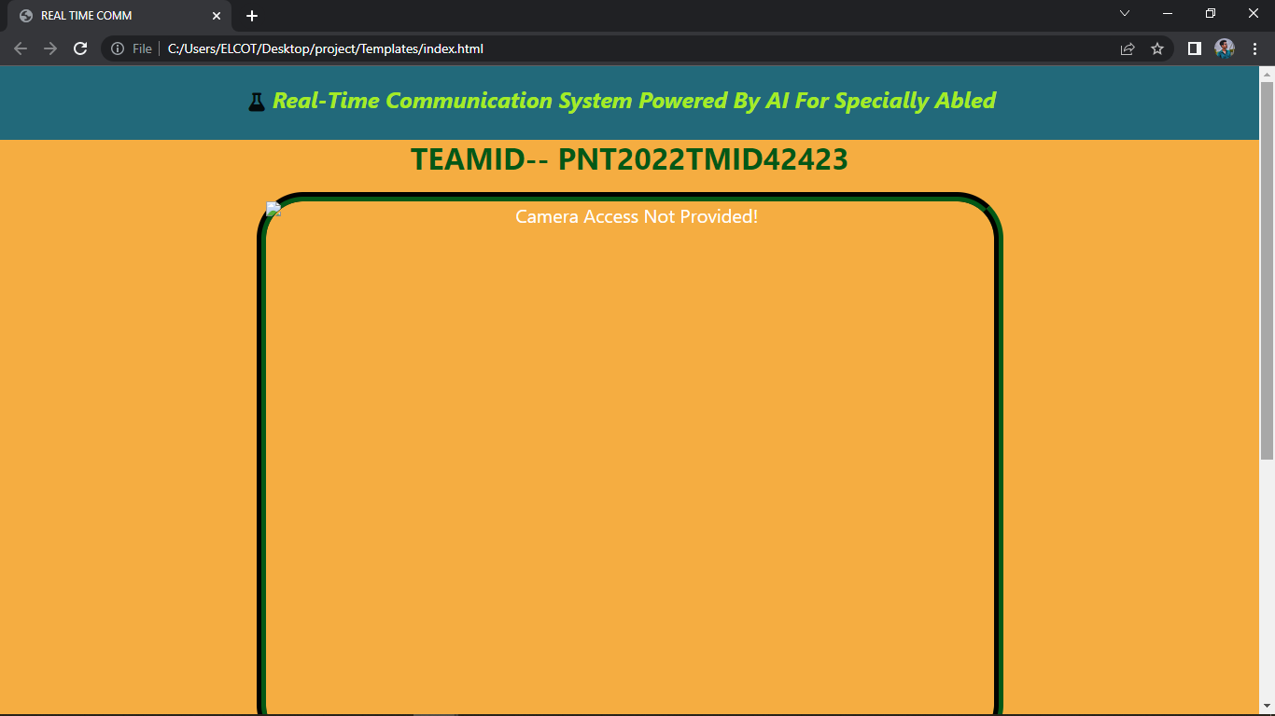

***7.2Feature 2***

***APPLICATION output***

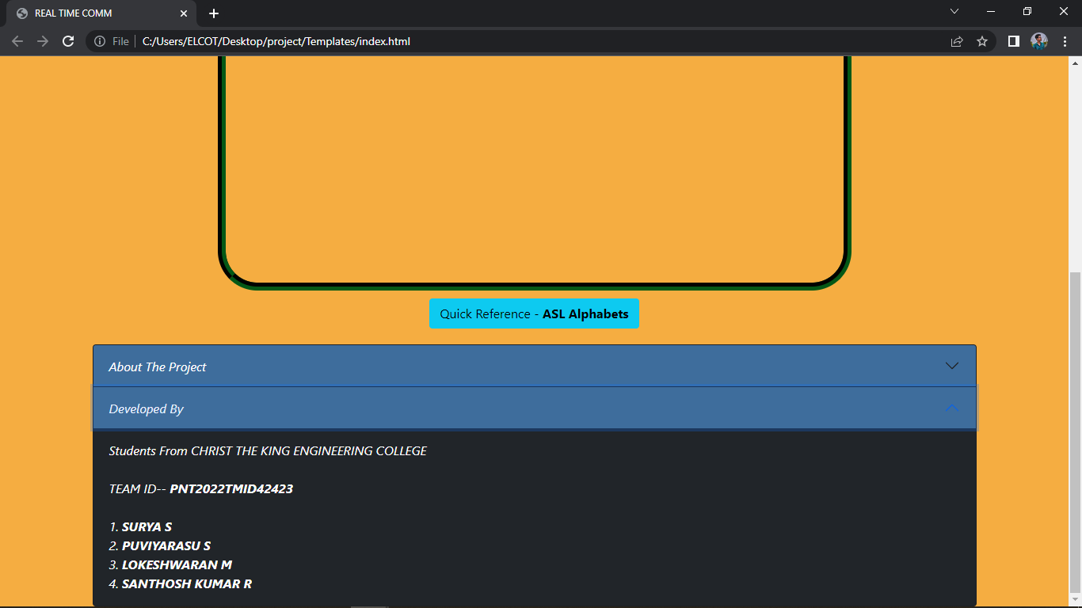

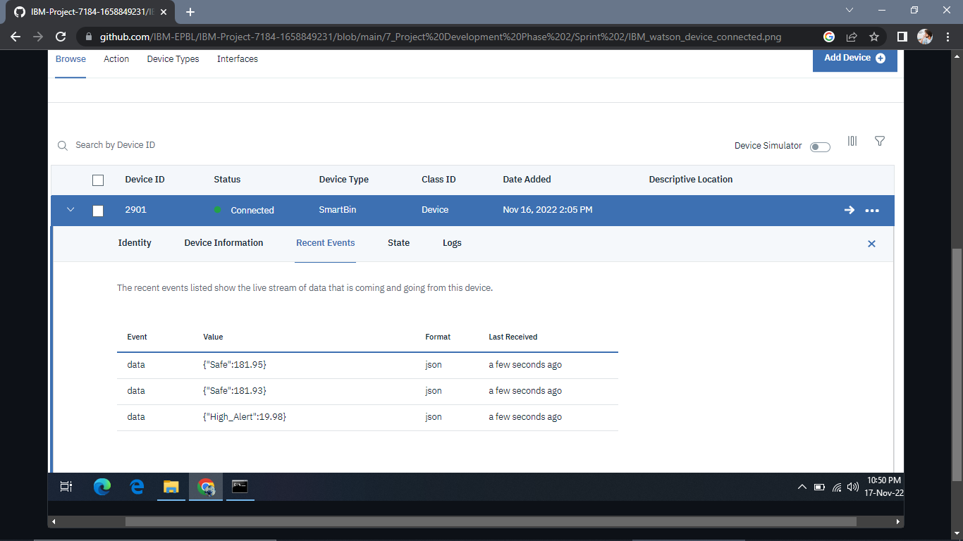 ***IBM Watson device connected***

**8. TESTING**

***8.1User Acceptance Testing***

|  |  |  |  |  |
| --- | --- | --- | --- | --- |
| **Section** | **Total Cases** | **Not Tested** | **Fail** | **Pass** |
| Print Engine | 7 | 0 | 0 | 7 |
| Client Application | 51 | 0 | 0 | 51 |

|  |  |  |  |  |  |
| --- | --- | --- | --- | --- | --- |
| **Resolution** | **Severity 1** | **Severity 2** | **Severity 3** | **Severity 4** | **Subtotal** |
| By Design | 10 | 4 | 3 | 3 | 20 |
| Duplicate | 1 | 0 | 3 | 0 | 4 |
| External | 2 | 3 | 0 | 1 | 6 |
| Fixed | 11 | 2 | 4 | 20 | 37 |
| Not Reproduced | 0 | 0 | 1 | 0 | 1 |
| Skipped | 0 | 0 | 1 | 1 | 2 |
| Won't Fix | 0 | 5 | 2 | 1 | 8 |
| Totals | 24 | 14 | 13 | 26 | 78 |

**9. RESULTS**

***9.1 Performance Metrics***

There are many different measurement frameworks, including the balanced scorecard, activity based costing, competitive benchmarking, and shareholder value added. Each of these pro- vides a unique and different lens through which to view an organization's performance.

**10. ADVANTAGES & DISADVANTAGES**

***ADVANTAGES***

➨AI drives down the time taken to perform a task. It enables multi-tasking and eases the workload for existing resources.

➨AI enables the execution of hitherto complex tasks without significant cost outlays.

➨AI operates 24x7 without interruption or breaks and has no downtime

AI augments the capabilities of differently abled individuals

➨AI has mass market potential, it can be deployed across industries.

➨AI facilitates decision-making by making the process faster and smarter.

***DIS-ADVANTAGES***

➨High Costs. The ability to create a machine that can simulate human intelligence.

➨No creativity. A big disadvantage of AI is that it cannot learn to think outside.

➨Make Humans Lazy,No Ethics,Emotionless,No Improvement.

**11. CONCLUSION**

AI-based tools can also be used to help with interactions by people who are unable to see content. Tools like Apple Siri and Amazon Echo and Alexa provide ways of interacting with content through a spoken dialogue model.

**12. FUTURE SCOPE**

The goal is to create computer intelligence programmes that can handle real-time problems and help organisations and everyday people achieve their goals. Machine games, speech recognition, language detection, computer vision, expert systems, robotics, and other fields have potential.

**13. APPENDIX**

*Source Code:*

<!DOCTYPE html>

<html lang="en">

<head>

    <meta charset="utf-8">

    <meta name="viewport" content="width=device-width, initial-scale=1.0, shrink-to-fit=no">

    <title>REAL TIME COMM</title>

    <link rel="stylesheet" href="https://cdn.jsdelivr.net/npm/bootstrap@5.1.3/dist/css/bootstrap.min.css">

    <link rel="stylesheet" href="https://use.fontawesome.com/releases/v5.12.0/css/all.css">

    <link rel="stylesheet" href="static/Navbar-Centered-Brand.css">

</head>

<body style="background: #f5ad41;">

    <nav class="navbar navbar-light navbar-expand-md py-3" style="background: #22697a;">

        <div class="container">

            <div></div><a class="navbar-brand d-flex align-items-center" href="#"><span

                    class="bs-icon-sm bs-icon-rounded bs-icon-primary d-flex justify-content-center align-items-center me-2 bs-icon"><i

                        class="fas fa-flask"></i></span><h4 style="color: #a5eb24; font-style: oblique; text-align: center;"><strong> Real-Time Communication

                    System Powered By AI&nbsp;For Specially Abled</strong></h4></a>

            <div></div>

        </div>

    </nav>

    <div>

        <h2 style="text-align: center; -webkit-text-fill-color: #045816;"><strong>TEAMID-- PNT2022TMID42423</strong></h2>

    </div>

    <section>

        <div class="d-flex flex-column justify-content-center align-items-center">

            <div class="d-flex flex-column justify-content-center align-items-center" id="div-video-feed"

                style="width: 800px;height: 600px;margin: 10px;min-height: 480px;min-width: 640px;border-radius: 50px;border: 10px groove #045816 ;">

                <img src="{{ url_for('video_feed') }}" style="width: 100%;height: 100%;color: rgb(255,255,255);text-align: center;font-size: 20px;"

                    alt="Camera Access Not Provided!">

            </div>

        </div>

        <div class="d-flex flex-column justify-content-center align-items-center" style="margin-bottom: 20px;"><button

                class="btn btn-info" type="button" data-bs-target="#modal-1" data-bs-toggle="modal";>Quick Reference

                -<strong> ASL Alphabets</strong></button></div>

    </section>

    <section>

        <div class="container">

            <div class="accordion text-white" role="tablist" id="accordion-1">

                <div class="accordion-item" style="font-style: oblique; background: rgb(33,37,41);">

                    <h2 class="accordion-header" role="tab"><button class="accordion-button" data-bs-toggle="collapse"

                            data-bs-target="#accordion-1 .item-1" aria-expanded="true"

                            aria-controls="accordion-1 .item-1"

                            style="font-style:inherit; background: #3E6D9C;color: rgb(255,255,255);">About The Project</button></h2>

                    <div class="accordion-collapse collapse show item-1" role="tabpanel" data-bs-parent="#accordion-1">

                        <div class="accordion-body">

                            <p class="mb-0">In our society, we have people with disabilities. The technology is developing day by day but no significant developments are undertaken for the betterment of these people. Communications between deaf-mute and a normal person has always been a challenging task. It is very difficult for mute people to convey their message to normal people. Since normal people are not trained on hand sign language. In emergency times conveying their message is very difficult. The human hand has remained a popular choice to convey information in situations where other forms like speech cannot be used. Voice Conversion System with Hand Gesture Recognition and translation will be very useful to have a proper conversation between a normal person and an impaired person in any language..</p>

                        </div>

                    </div>

                </div>

                <div class="accordion-item" style="font-style: oblique; background: rgb(33,37,41);">

                    <h2 class="accordion-header" role="tab"><button class="accordion-button collapsed"

                            data-bs-toggle="collapse" data-bs-target="#accordion-1 .item-2" aria-expanded="false"

                            aria-controls="accordion-1 .item-2"

                            style="font-style: oblique; background: #3E6D9C;color: rgb(231,241,255);">Developed By</button></h2>

                    <div class="accordion-collapse collapse item-2" role="tabpanel" data-bs-parent="#accordion-1">

                        <div class="accordion-body">

                            <p class="mb-0">Students From CHRIST THE KING ENGINEERING COLLEGE<br><br>TEAM ID-- <strong>PNT2022TMID42423</strong><br><br>1. <strong>SURYA S</strong> <br>2.

                                <strong>PUVIYARASU S</strong> <br>3. <strong>LOKESHWARAN M</strong><br>4. <strong>SANTHOSH KUMAR R</strong>

                            </p>

                        </div>

                    </div>

                </div>

            </div>

        </div>

    </section>

    <div class="modal fade" role="dialog" tabindex="-1" id="modal-1">

        <div class="modal-dialog" role="document">

            <div class="modal-content">

                <div class="modal-header">

                    <h4 class="modal-title">American Sign Language - Alphabets</h4><button type="button"

                        class="btn-close" data-bs-dismiss="modal" aria-label="Close"></button>

                </div>

                <div class="modal-body"><img src='ASL_Alphabet.jpg' height=100% width="450px"></div>

                <div class="modal-footer"><button class="btn btn-secondary" type="button"

                        data-bs-dismiss="modal">Close</button></div>

            </div>

        </div>

    </div>

    <script src="https://cdn.jsdelivr.net/npm/bootstrap@5.1.3/dist/js/bootstrap.bundle.min.js"></script>

</body>

</html>

***GitHub & Project Demo Link***

GitHub: gh repo clone IBM-EPBL/IBM-Project-7542-1658889257